Chapter 3 Exercises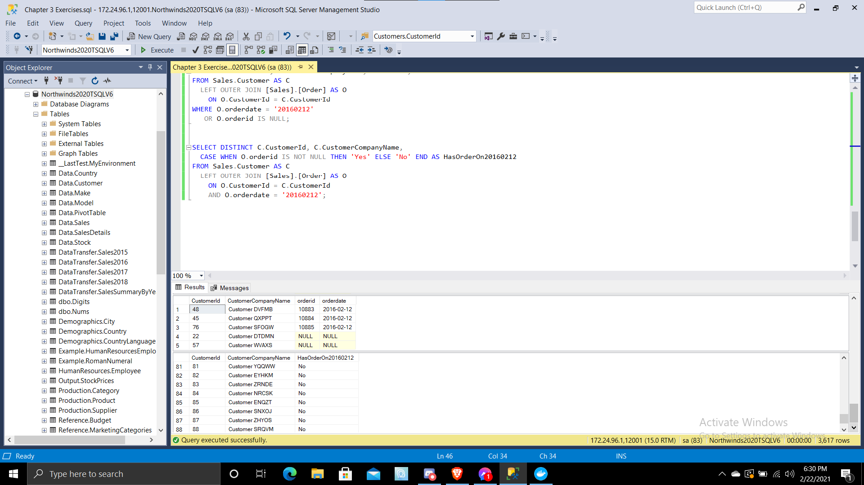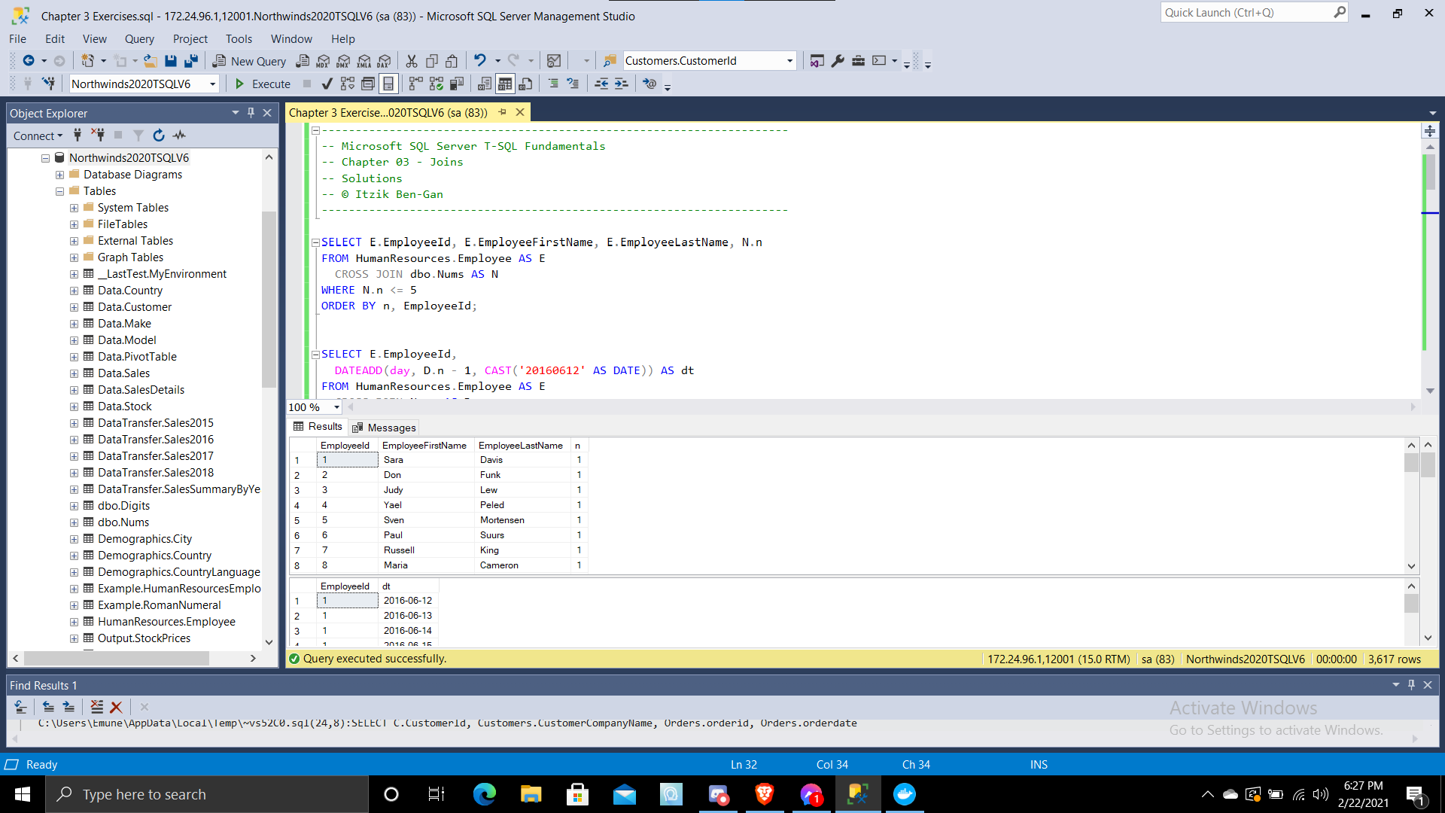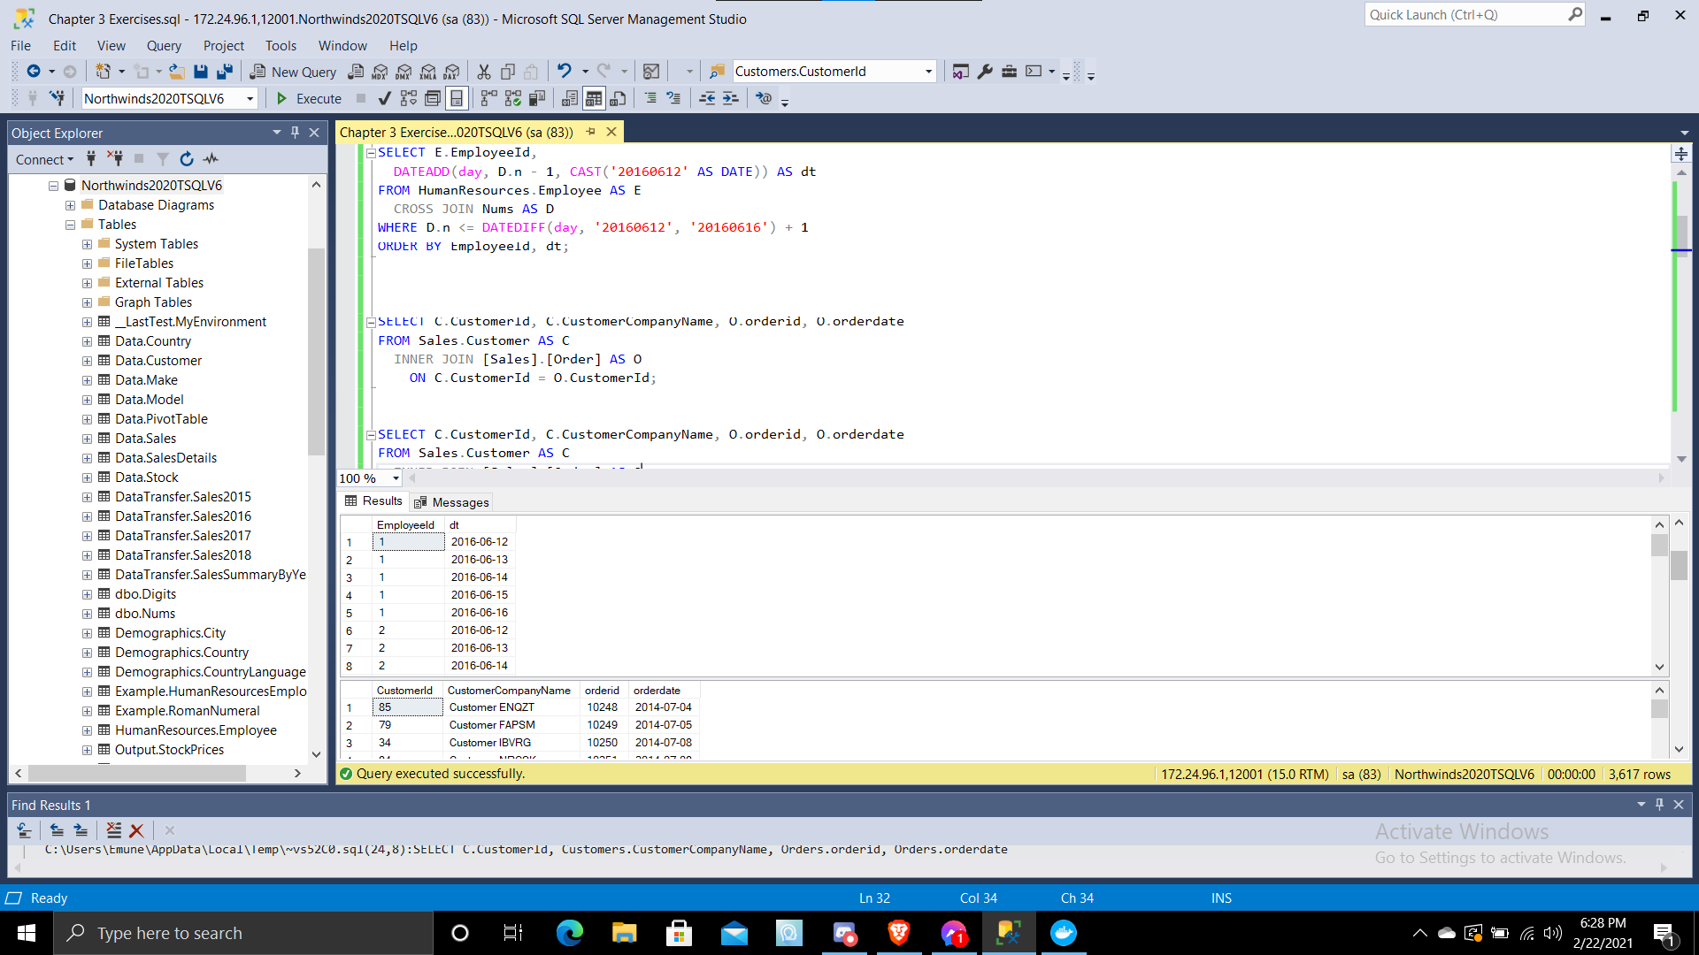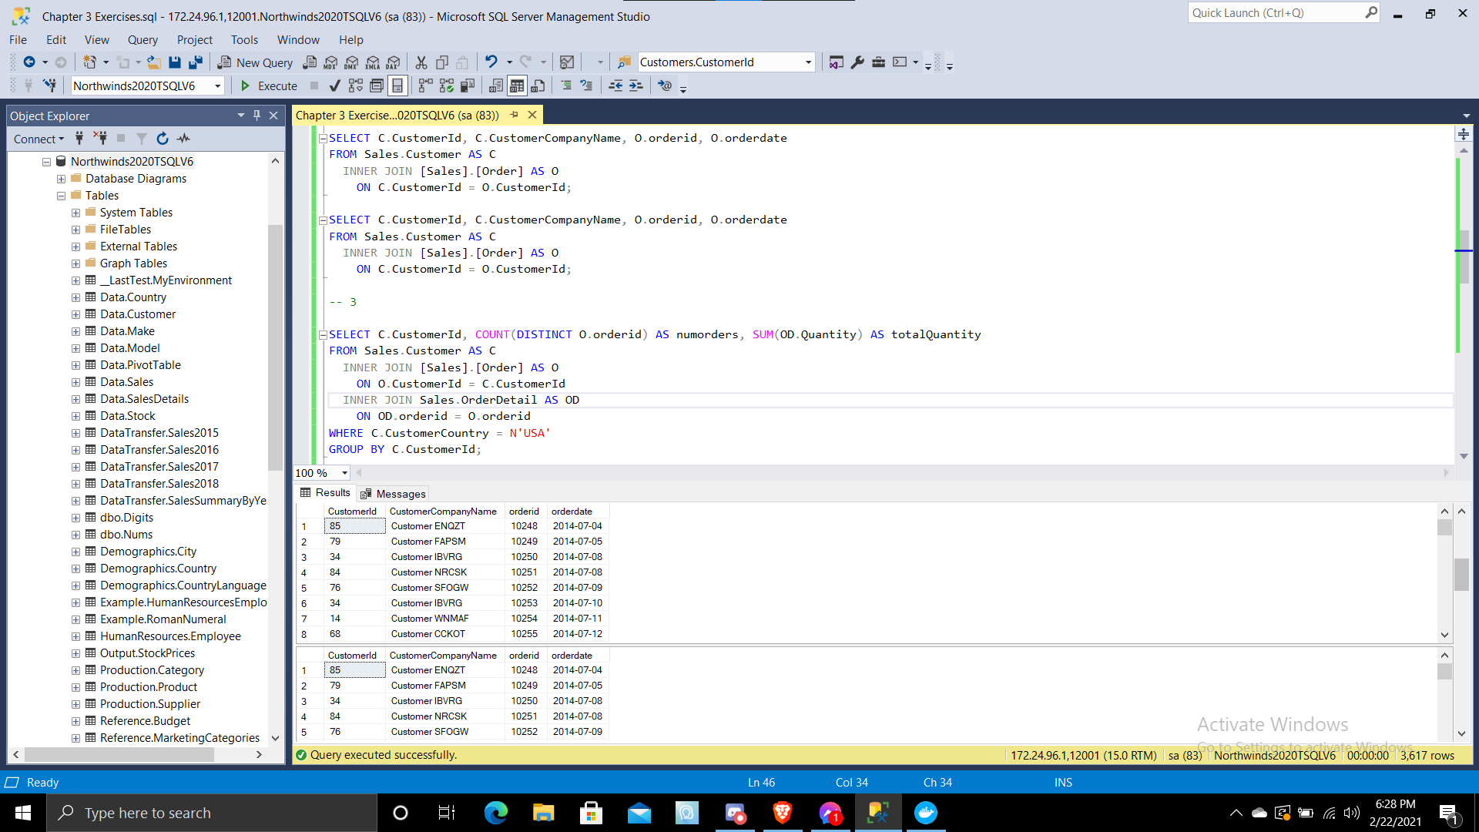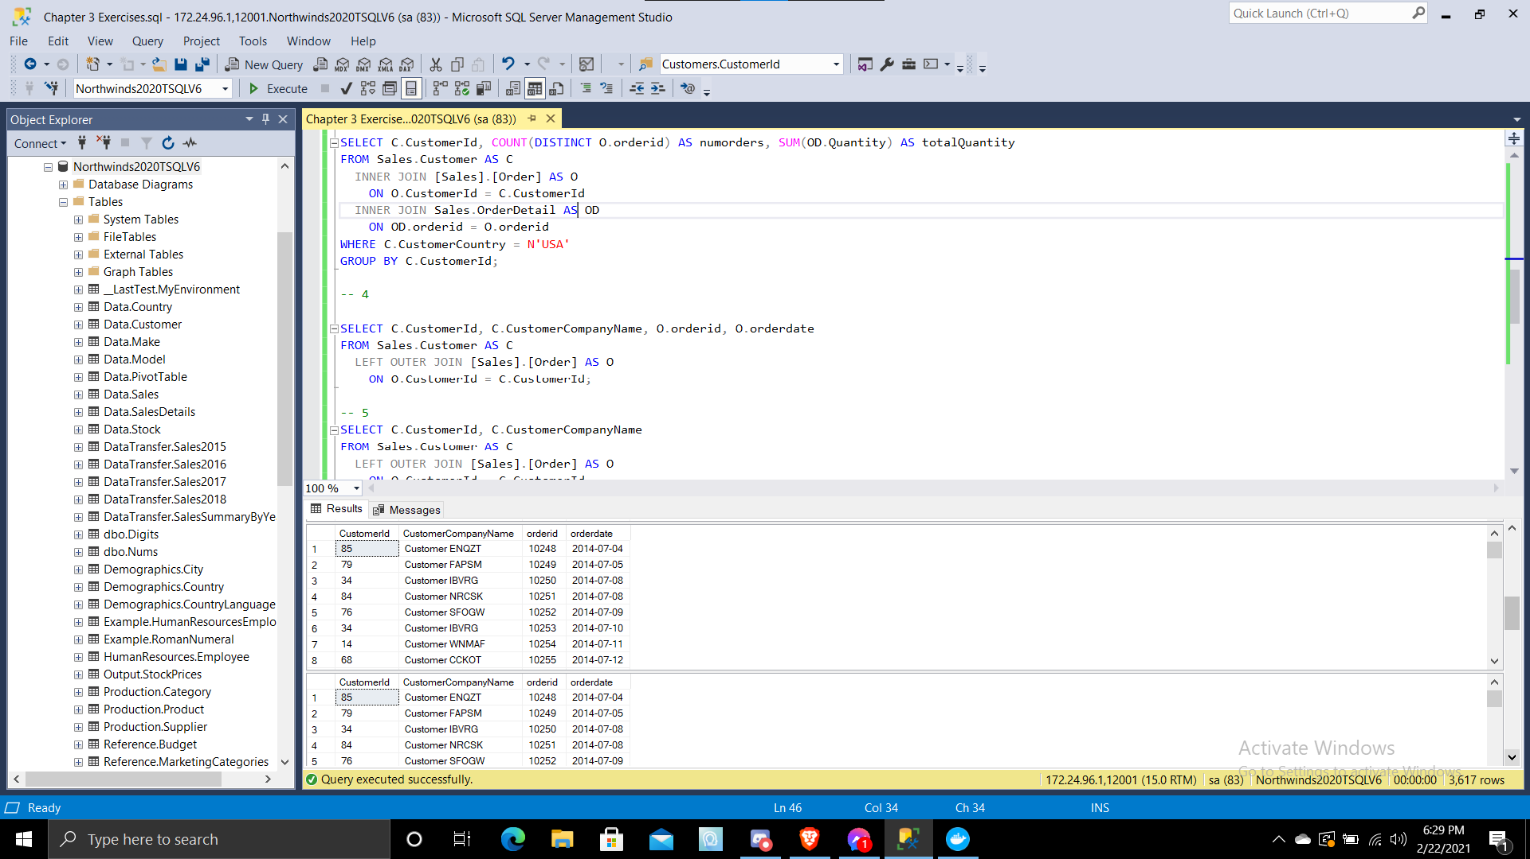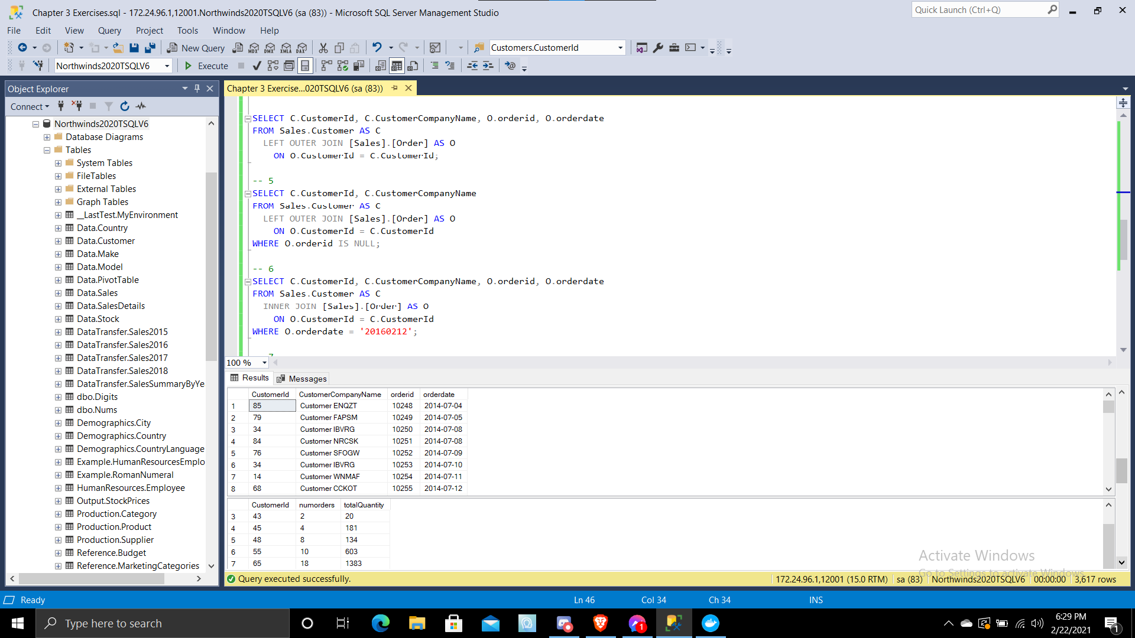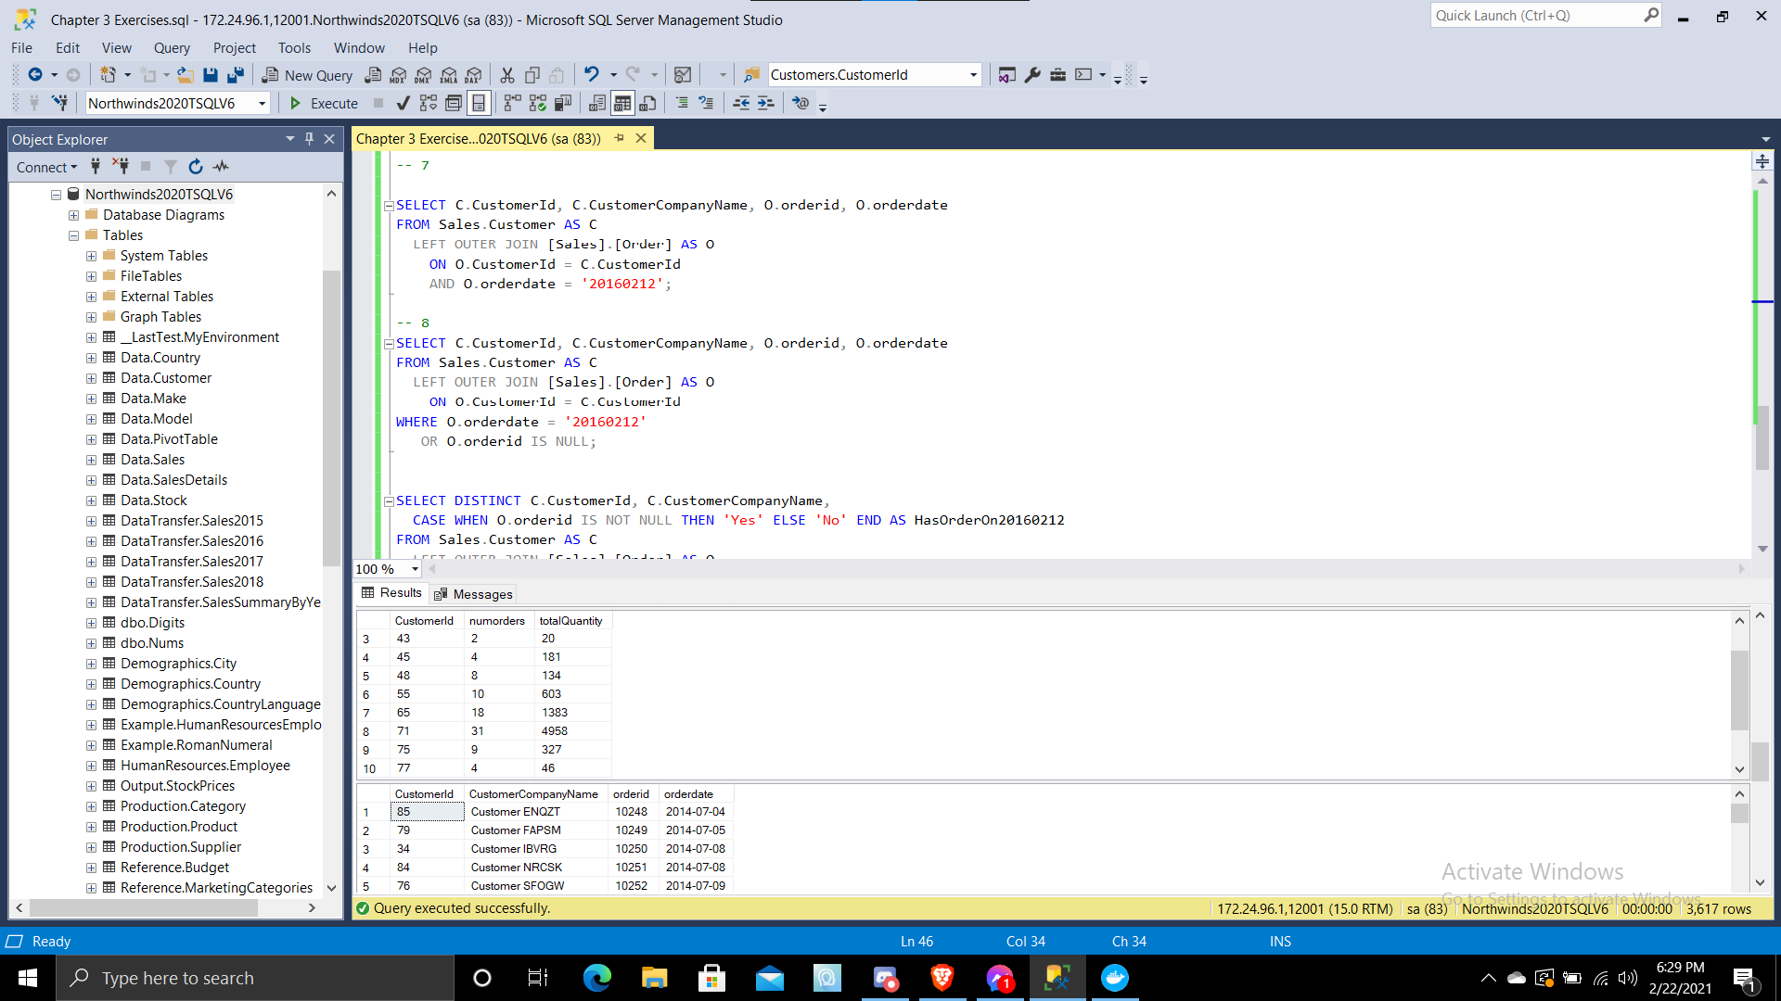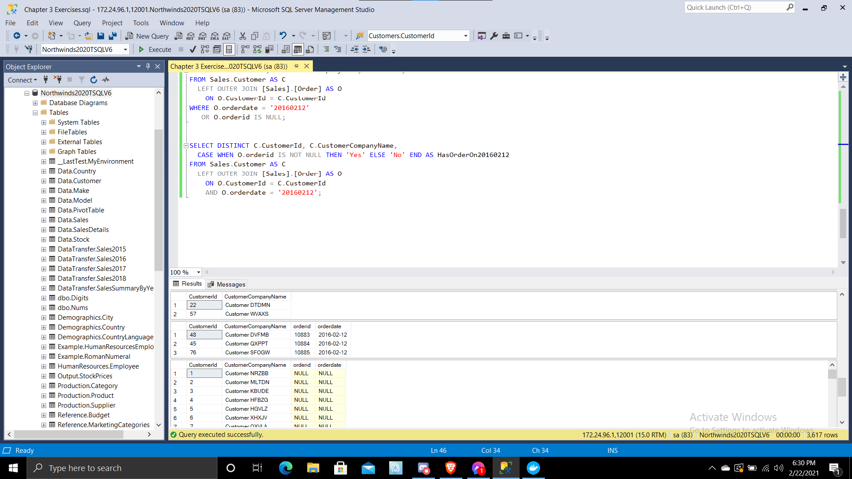

(45 rows affected)

(45 rows affected)

(830 rows affected)

(830 rows affected)

(830 rows affected)

(13 rows affected)

(832 rows affected)

(2 rows affected)

(3 rows affected)

(91 rows affected)

(5 rows affected)

(91 rows affected)

Completion time: 2021-02-22T21:25:53.4523350-05:00